Transport Driver Safety Induction

API – Dandenong
35 – 39 South Park Drive
Dandenong South
VIC 3175

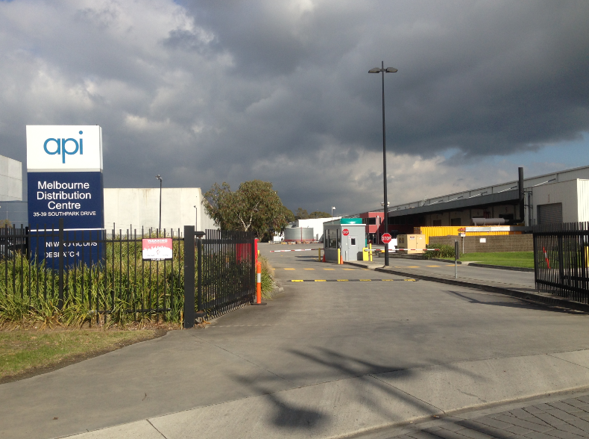

TABLE OF CONTENTS:

Introduction to API
Site Map
Conditions of Entry
Security Process
Sub-Contractor Requirements
Expectations and Contact Information
What If?
Acknowledgement

Contact Information
Vicki McClelland (API Transport Manager) – 0428 511 569
Transport Desk (Door 9) - (03) 9904 0750
Debbie Buck (Transport Supervisor) 0418 384 028
Security – (03) 9904 0513 / 0488 650 018

Introduction to API Transport:

- The Transport desk is located inside at Door 9, at 35-39 South Park Drive Dandenong.
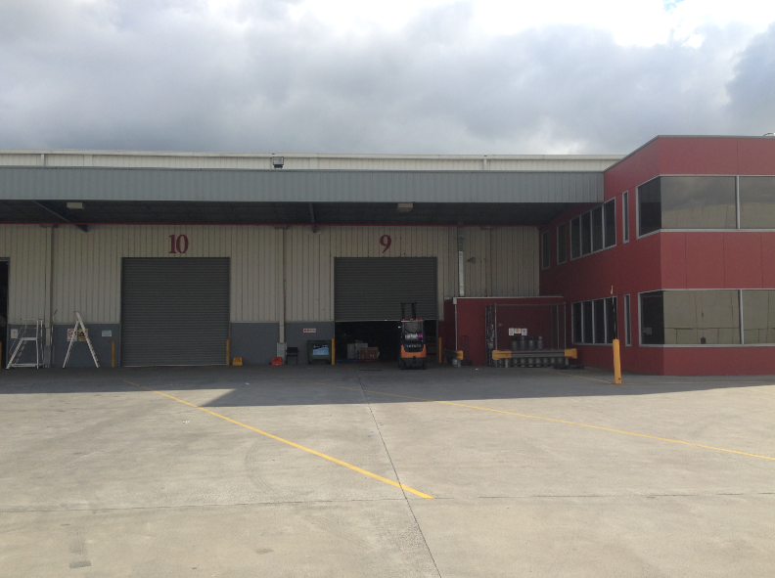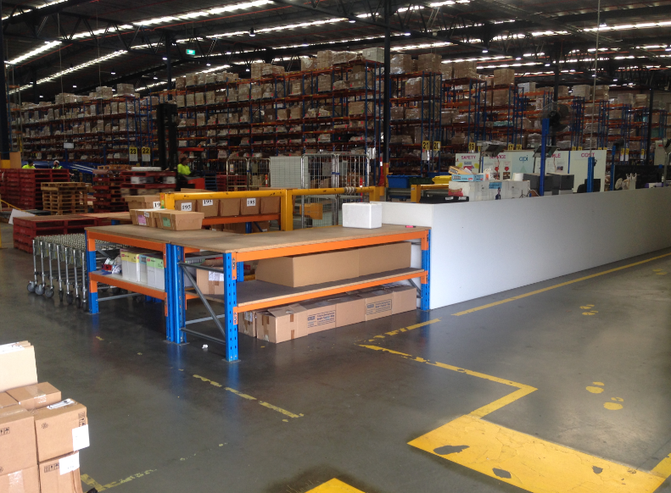
- All drivers must be inducted to site and have completed the API induction prior to commencing work within API.
- You are required to enter via the security point off the roundabout at South Park Drive.
Note: No passengers are permitted while working for API.
- Observe the 10KPH on site SPEED LIMIT.
- Never enter any areas of the Site to which you are not authorized or inducted into.
- Cooperate with any API Security Personnel when asked.
- It is a requirement that Sub Contractors keep their vehicles out of the dispatch areas unless loading or unloading ULDs. Both of these tasks are to be completed with urgency and vehicles moved immediately after completion.

Site Map

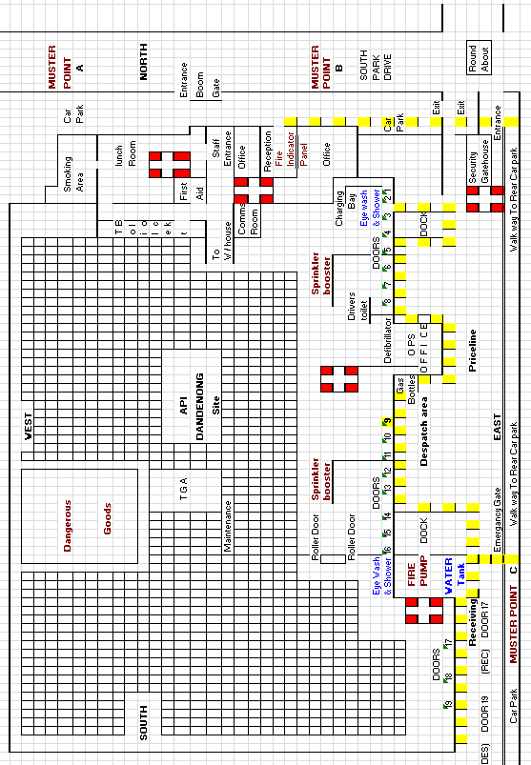
Pharmacy Despatch (AM) & Outbound Line Haul Loading Areas (PM)
Recyclables Unloading Area (Totes, Eskies, RUM Bins) & Credit Returns
Inbound Line Haul - Dock 16, Doors 17 - 19. Door 5 by exception

Victoria Locals Loading Docks (14 & 15)

API Conditions of Entry

- All deliveries must have prior booking / Timeslot / PO number / Invoice and or consignment note.

- Driveway must be treated in accordance with Victorian road rules.

- Incoming traffic must drive to the left and outbound from site must remain to the right hand side of driveway.

- All Inbound deliveries must park along the fence line until called up by a Receiving or Transport Dept. Team member.

- All outbound drivers must have prior booking/timeslot.
- All Outbound drivers to report to door 9 Transport desk (Outbound Deliveries Only).

- All Inbound Deliveries to report to Door 17

- Recycle totes to be sorted and placed on pallets provided at door 8. Pharmacy SRA returns to be placed in cages provided at door 6.

- Site speed limit must be adhered to at all times, 10 Kph.

- All drivers must wear correct PPE, high visibility clothing and steel cap safety footwear.

- Drivers must stand in safety zones at all times whilst site MHE is mobile. When you need to attend to your vehicle during the unloading or loading of the vehicle, site MHE will cease to operate.

- No family or friends are to travel in vehicles as passengers

- Children are not permitted on site even within vehicles.

- Smoking is prohibited on site.

- No pets allowed on site.

- Driver must remain in driver safety zones whilst on mobile phone.

- Mobiles are prohibited to be used in the safety zone next to the gas cylinder storage area next to Operations office. (please refer to site map area coloured in blue)

- If you are injured on site you must report it to site management immediately.

IN AN EMERGENCY – LOUDSPEAKER TONES & ASSEMBLY POINT

IF YOU HEAR THIS ........ ‘BEEP – BEEP – BEEP’

- Stay where you are
- This is the ALERT tone
- This sound tells the API Fire Wardens to get ready

IF YOU HEAR THIS ........ ‘WOOP – WOOP – WOOP’

- This is the tone to EVACUATE
- Follow the instructions of the API Fire Wardens
- In the event of an evacuation the emergency assembly point for Drivers is located on the yard on the far Eastern side; an emergency gate is here to access the car park.
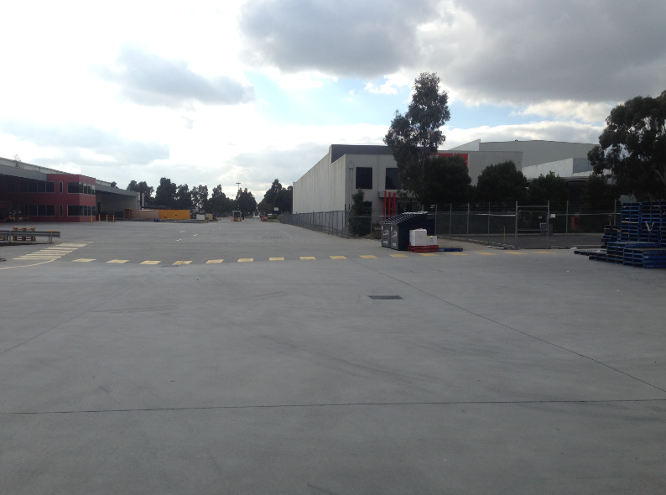

BE A TEAM PLAYER- WORKING IN HARMONY WILL ASSIST BOTH PARTIES IN EFFICENT OPERATION.

Sub-Contractor requirements are:

- To be neat, tidy, hygienic at all times.

- To wear a uniform which compromises of:
  - Hi -visibility uniform
  - Steel capped footwear
Expectations

- Each day you are to arrive on site at your scheduled pick up or delivery time.
- When you arrive you are to provide the gatehouse with your driver number and job number for the day.
What If?
You arrive on site and nobody is there to accept the delivery?
- Contact your Supervisor immediately to inform. Await a response from the Supervisor with instructions.
I encounter a breakdown or am involved in an accident whilst on the road?
Contact your Manager immediately and inform him of the following:
- Are you injured?
- Is anybody else injured?
- Was anybody else involved?
- Have the emergency services been contacted?
- What is the situation with your vehicle? Is it drivable?
- Were there any witnesses to the accident?
- Was there API product still loaded on the truck?
- If the vehicle is drivable and you are OK, can you return to your depot for a briefing?
- We value human life above all else. When it comes to safety, we will not compromise.

In performing a delivery I have missing or damaged some goods?
- Contact your Site Supervisor immediately.
- Complete an incident report form
- Take photos of the damaged stock.
- Make sure you advise your Manager of any damaged goods so that API can be notified of this.

Outbound Security Process

Line haul

- All line haul vehicles over 14 pallets will be subject to a pre load check list being completed by forklift driver.

- All Outbound despatch to be allocated a booking number this can be provided by supplier, line haul vehicles are provided daily pickup times.

- The driver of vehicle and a transport team member to seal truck and check all seal numbers are correct. Driver and transport member to sign con-note manifest.

- Gate house to be handed paperwork and seal numbers to be checked. If seal numbers do not match, the truck is not to leave site. Transport Manager to be notified by Gatehouse.

ACKNOWLEDGEMENT FORM

DISTRIBUTION CENTRE

SAFETY INDUCTION FOR DRIVERS

I,

Of (Company Name):

Driver Number: ____________________

Acknowledge that I have participated in API’s Safety Induction and understand the Occupational Health and Safety requirements of the Distribution Centre and agree to abide by them at all times whilst working on or visiting the site.

I acknowledge I must carry my access card and pass at all times and present it if requested.

I acknowledge I must ensure prior to commencing work on or visiting any other API site I will familiarise myself with their site specific induction.

I understand that failure to comply with API DC site requirements and directions may result in my being refused entry to the API DC site.

Signature

Date

API Representative

Date

DISTRIBUTION CENTRE SAFETY INDUCTION
COMPETENCY TEST FOR DRIVERS

The following questions have been designed to assess your understanding of the Distribution Centre Safety Induction for Drivers.

Place a tick in the box that best represents the correct answer.
(Please tick ✓)
Question | True | False
All instructions given by the gatehouse must be followed.
Advisory signs must be obeyed.
Smoking is allowed anywhere in the Distribution Centre.
Drivers are allowed to walk inside the Distribution Centre’s warehouse whenever they want.
When the “Evacuate” tones sound via the evacuation PA system employees and visitors must evacuate the Distribution Centre immediately.
Drivers are not required to report any accidents / incidents / injuries.
First Aiders are available to assist the injured if required.
Drivers must wear fully enclosed safety capped footwear.
Drivers are not required to wear Hi-Visibility clothing.
Traffic flows in a one way counter clockwise direction.
Drivers must be stationary and safely away from traffic when using mobile phones.
Drivers are free to roam the site at their leisure.

This Drivers Induction is only valid for 12 months after date of issue.

