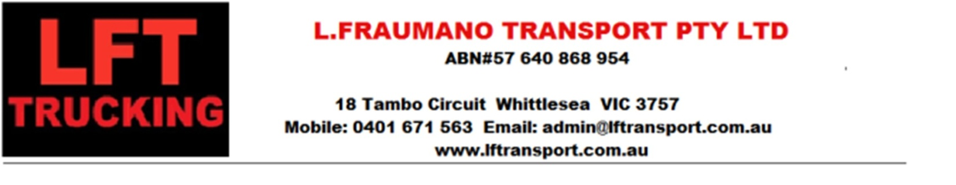

**LFT - CONTRACTOR APPLICATION FORM**

COMPANY NAME:

ACN# ABN:

ADDRESS:

PHONE: MOBILE:

EMAIL ADDRESS:

DIRECTOR

Mobile Email

**BANKING DETAILS: -** ACCOUNT NAME:

Account # BSB:

**INSURANCE DETAILS –**

You will also require the following documents on hand for uploading to our server once you have received your login details :

* Fully Comprehensive Motor Vehicle/Truck Insurance for All Trucks.& trailers (including 1million dangerous goods insurance)
* Public Liability, Marine & Non Owned Trailer(for PM owners)
* WORKCOVER Certificate of Currency
* Recent Vehicle Service/Maintenance records for all vehicles
* **ALL DRIVERS**

Please download DRIVER APPLICATION FORM and submit all documentation.